July at PUMC is a Celebration

July 4 - We Celebrate God’s Unconditional Love:
God Loves YOU and there is nothing you can do about it.

July 11 - We Celebrate Kindness
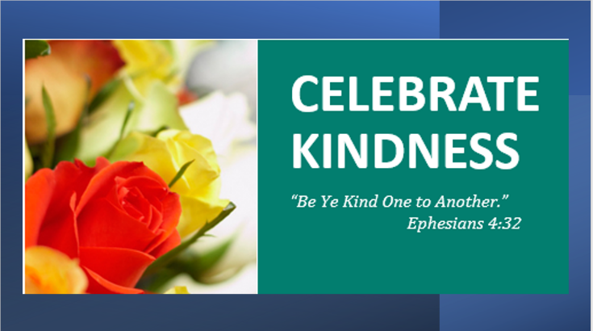

July 18- We Celebrate Our Children
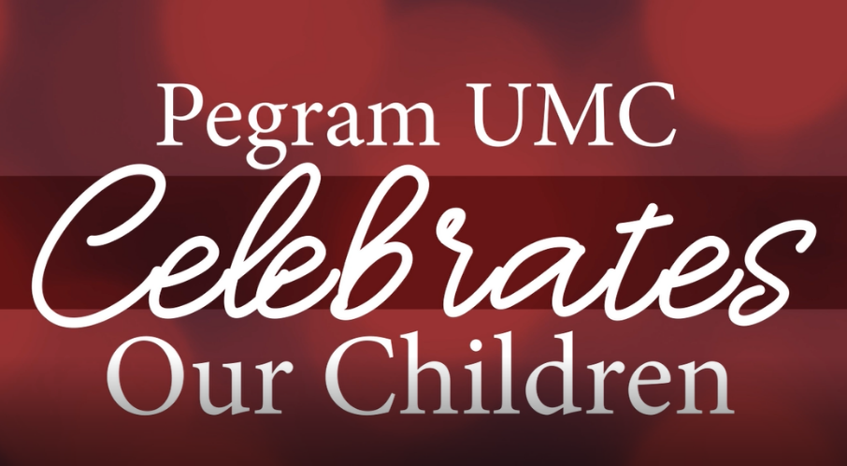
The link to the video: https://youtu.be/KZMWv7kFvdo

July 25- We Celebrate Community Join us on Sunday at 10:30

