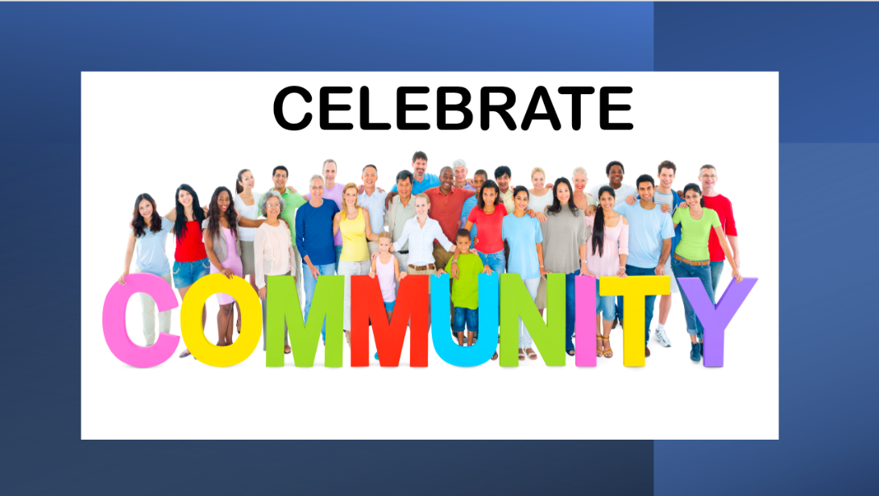

Dear Friends,
What a week to celebrate community! I walk over to the church almost everyday and everyday this week our church has been filled with folks working to take the love of Jesus out into the community. So many of you were there, hosting the seniors of our community for lunch, or getting all of those backpacks ready for the children of our area. What really caught my attention was the fact that our folks were joined by so many people from other churches. It was truly the community of faith in action and I believe that God moves through community.
If you want to see God moving in the world, stop by the Ark Backpack event at Pegram Park on Saturday. (11-1pm) Our church will have a booth there and more than 100 children will come to get supplies for school and lots of other treats. It will be my first time at this event and I can’t wait.
One of my professors at Vanderbilt said, “People often ask that familiar question, ‘What would Jesus do?’ But I think the better question is what IS Jesus doing in the world today?”
I say with great confidence that I am seeing Jesus at work in Pegram this week. Jesus is moving through the ladies in the kitchen every Wednesday, through the men and women (and teenagers) who unpacked and repacked school supplies and those who will host the booths and hand out tokens of love on Saturday.
We are celebrating community this week; join us on Sunday for the celebration.
See you on Sunday.
Grace and Peace,
Pastor Myra
248 835 5873 myramoreland8@gmail.com

