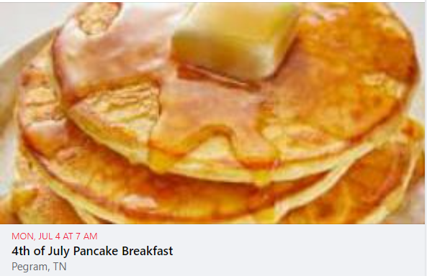
Dear Friends,
There are more than a few attachments today because there are so many things going on as we transition into July. First on the list is the Pancake Breakfast on July 4th. If you can volunteer to help, don’t miss this chance to experience the kitchen in full swing. I promise lots of laughs and plenty of fun (and work) for those cooking in the kitchen or serving in the hall.
I’m also attaching an invitation to a reception for Rev. Zach Moffatt. I know several of you were able to watch as Zach was ordained as an Elder in full connection with the United Methodist Church and you are all just beaming with pride at his accomplishments. If you can’t make the reception, you might want to send him a note of congratulations.
And finally,. Yes…… my time as your pastor is quickly coming to a close. I spent Tuesday with Pastor Denise and I leave with great confidence that you are all in good hands. I have laughed thinking about how many times in my life I came out I-40, got off at McCrory Lane and took a left. My world was left of McCrory. Oh how that has changed in this past year. And now that I know where you are and how wonderful you all are, you know I will not be able to stay away. Look for me to drop in from time to time just to say hello. You all have an open invitation to come to Troy, the parsonage of Troy First UMC is open for visitors… (or it will be once, my things arrive…lol).
I will see you all on Sunday. We’ve got special music planned and some we’ll take time for hugs and handshakes.
See you Sunday.
Pastor Myra
P.S. Pancake breakfast details are below:
4th of July Pre-Parade Pancake Breakfast – Pegram United Methodist Church’s annual Pancake
Breakfast is 7-9 a.m. Mon., July 4. Breakfast includes fluffy delicious pancakes, sausage and a beverage.
The full stack is $8 for 3 pancakes and 2 sausage patties. Short stack is $5 for 2 pancakes and 1 sausage
patty. Fellowship opportunities abound for meeting your neighbors and candidates for elected office.
The church is located at 479 Thompson Rd., across from the Pegram ballfields. This event is the annual
kick-off for Pegram’s full day of holiday fun.

