Missions for November and December
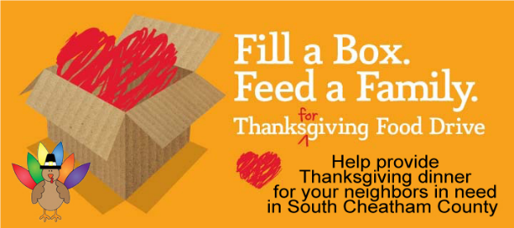
Bring items or boxes to the church by Saturday, Nov. 13th. Each box will need to include, but is not limited to:
- a box (or bag) of potatoes,
- 2 cans of vegetables (such as green beans or carrots),
- a pouch or can of brown gravy, stuffing mix,
- a can of sweet potatoes,
- marshmallows,
- package of cookies or other dessert
- a can of cranberry sauce
Some extras could include tea bags, candy or other things that your family enjoys with their Thanksgiving meal.
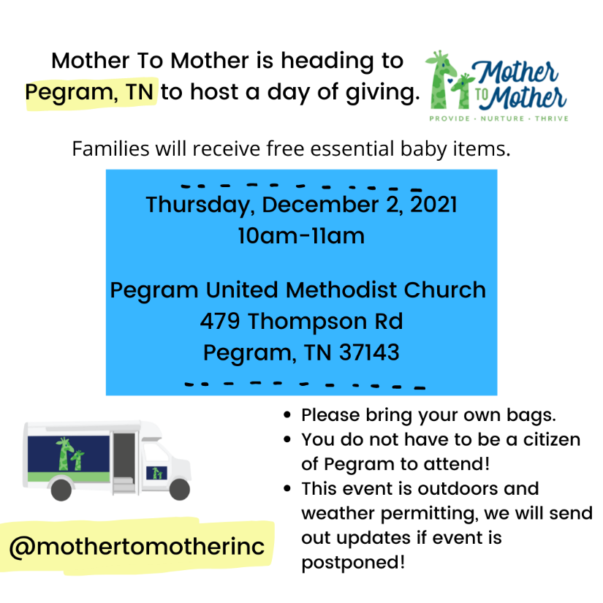
Information on the Angel Tree is coming soon……

